HANDBALL

INSTRUCTIONS
This Learning Packet has two parts: (1) text to read and (2) questions to answer.
The text describes a particular sport or physical activity, and relates its history, rules, playing techniques, scoring, notes and news.
The Response Forms (questions and puzzles) check your understanding and appreciation of the sport or physical activity.

INTRODUCTION
Handball is one of the simplest of the sports, both to understand as a spectator and to learn as an active participant. It’s also an excellent way to stay in shape, since it combines many of the benefits of both calisthenics and jogging.

HISTORY OF THE GAME
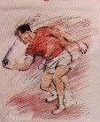
Handball was first played in ancient Rome. In fifteenth century Spain and France, it was played as “pelota.” It was called “fives” in England in the sixteenth century. The current version of the game was developed in Ireland in the mid eighteenth century. Phil Casey built the first U. S. handball court in 1886.
Handball enjoyed a huge increase in popularity in the U. S. during the “fitness movement” that swept the country in the 1970s and 1980s. Handball fans saw the sport as a body conditioner which, unlike running or riding stationary bicycles, provided a social context for a demanding form of aerobic exercise.
Team handball, which incorporates many ele-
ments of handball as described below under “Basic Concepts,” was invented around 1890 by Danish track and field athletes as a conditioning sport. It was team handball that developed into the Olympic version of what is called “handball” in Europe and “team handball” in the United States.
Rules were standardized in 1924 by the International Handball Federation (IHP). Eleven nations met at the Olympic Games in 1928 to form the International Amateur Handball Federation and write the international handball rules. Handball was removed from the Olympic program in 1948. The U. S. Team Handball Federation (USTHF) was formed in 1959, and team handball was reinstated in the Olympics in 1972.

HOW THE GAME IS PLAYED

BASIC CONCEPTS
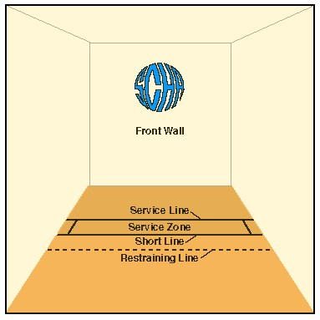
The crux of the game of handball is to keep returning the ball to the front wall. If the receiver does not return the ball, the server scores a point. If servers fail to return the ball, they lose the serve. A player can score only when he/she is serving. The first player to reach 21 points is the winner. The rules of the game can be summed up as follows:
- The server bounces the ball, then hits it against the front wall. The serve must bounce back beyond the short line into the court. A fault occurs if the ball hits the ceiling or any of the other walls.
- If two faults are committed, the server loses the serve.
- The receiver must return the serve to the front wall. The ball is allowed to hit a side wall, for example, before hitting the front wall. The ball cannot touch the floor before it reaches the front wall.
- The receiver cannot cross the short line until the ball has crossed the short
line first after a serve.
- During the rally, either the server or receiver can return the ball before it touches the floor. The ball must be returned before it bounces on the floor twice.
The game of handball is organized so that two, three or four players can play. In Olympic team handball, each side has seven players. If only two people play, one is the server and one the receiver. When four persons play, it is called a doubles game. The server and his/her partner are the serving team and the other two players are the receiving team.
“Cut-throat handball,” or a three-person game, pits one person against the other two. One player is the server while the other two are receivers. This structure continues on a rotating basis until the first player with 21 points wins.

GAME STRATEGY
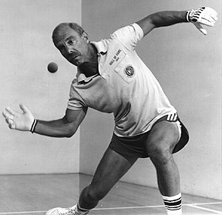
The game of handball is comprised of much more than running back and forth inside the court and hitting the ball. The game requires careful planning and strategizing in order to handle the various types of shots in the best way. Key skills for the handball player include learning to anticipate, concentrate and control.
It is often difficult for a more experienced player to anticipate shots when playing with a beginning player. New players often do things that seem illogical, and sometimes perform the various strokes
poorly. It is helpful for the beginner to practice observing how more experienced players play and also simply to watch the flight of the ball around the court. With practice, it becomes easier to anticipate an opponent’s next move.
Concentration is a second major ingredient for success on the handball court. A handball player’s top priority during the game is to think about what the ball is doing or what it is going to do. Losing focus and concentration nearly always results in losing points, and perhaps, losing the game!
Maintaining control over the game at all times also can help a beginning player develop into a winning player. Control means remaining calm, collected, focused and confident. Being out of control means not thinking about strategy, not watching the ball, and/or losing one’s temper if a shot is missed.

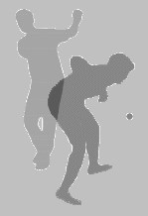
PLAYING TECHNIQUES

FOOTWORK
A player’s hand work is not enough to win a game of handball. Footwork is equally essential to the skilled player.
If a player is right-handed, he or she will shift the body weight from the right back foot to the left front foot as the ball shifts. The legs should remain slightly flexed so that when the ball comes, the player can step into the ball.

BASIC STROKES
There are three basic strokes used in handball: the overhand, the sidearm and the underhand. While all three strokes are considered crucial to the game, the sidearm is thought to be the most important.
The overhand stroke in handball closely resembles a tennis overhand. But instead of a racquet hitting a tennis ball, the handball player’s palm and cupped fingers strike the handball. The ball is then stroked upward toward the ceiling and the arm follows through on the shot. This stroke requires great control and a “feather touch.”
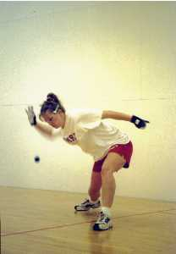
The sidearm stroke is most frequently used because it is the serving stroke. The sidearm also allows the player to return the ball before it falls into the back court and therefore, is harder to return. The ball is returned as it crosses the mid-line of the player’s body. The player’s weight shifts from the back foot to the front foot, with the body kept low. The swing is parallel to the floor.
The contact point with the ball is at the knee.
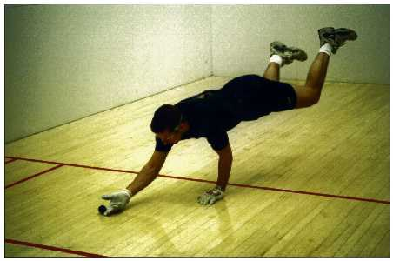
The underhand stroke is similar to a digging motion. This stroke is used mainly for “digging out” low balls and returning them to the front wall. Professionals advise against using this stroke for rallying, or exchanging shots with the opponent. Players often look like they are bowling when performing the underhand stroke.

BASIC SHOTS
There are also three basic types of shots in handball: the passing shot, the kill shot and the ceiling shot. All three shots are used in conjunction with all three types of strokes.
- The passing shot does just that—it passes by the opponent. When an opponent is in front of a player, the player with the ball hits the ball to the front wall so that the ball rebounds out of the opponent’s reach. This shot typically scores more points than any other type of shot.
- The kill shot, properly executed, is usually unreturnable. The ball is close to the floor, aimed at the bottom of the front wall. The player is in a crouching position as the ball is hit. The ball should be hit low so that it comes off the front wall with such a low bounce that there is no chance for the opponent to return it.
- The ceiling shot is hit off the ceiling, close to the front wall. This is a defensive shot used to move an opponent out of the front court. The ceiling is considered the fifth wall in handball, as this shot proves. A good ceiling shot will often fluster and confuse an opponent who cannot handle a high overhand stroke.

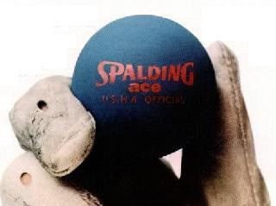
EQUIPMENT AND CLOTHING
Handball is played on various types of courts, including those with one, three and four walls. The most common type of court is the four-wall court, although such a court actually has five hitting surfaces if one counts the ceiling.
The regulation handball court is 20 feet wide and
40 feet long. The front wall is 20 feet high while the back wall is at least 12 feet high. The service zone runs the width of the court and the service line is 15 feet from the front wall.
The rubber ball used during the game weighs only two ounces. Although it is small and soft, the ball can sting the player’s hand each time it rebounds from the wall. As a result, all serious handball players wear deerskin or goatskin handball gloves while playing.

HANDBALL NOTES AND NEWS
Although handball does not receive the publicity in the popular press enjoyed by football or basketball, over 3,000,000 players are registered worldwide with the International Handball Association. Add to this figure the number of unregistered people who play handball regularly at health clubs and other facilities and you will begin to understand just how popular this sport really is.
Team handball is an Olympic sport. Once an 11-man-per-side sport, it evolved into a 7man-per-side sport between 1948 (when it was dropped from the Olympic roster) and 1972 (when it was reinstated). In 1976, women’s team handball was instituted. Team Handball was a part of the program at the 2004 Summer Olympics in Athens, Greece.
Handball - Men’s Team Handball Medal Results, 2004 Olympics:

Medal Country
Gold Croatia
Silver Germany Bronze Russia
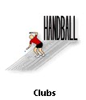
Handball - Women’s Team Handball Medal Results, 2004 Olympics:

Medal Country
Gold Denmark
Silver South Korea
Bronze Ukraine
Handball is also a popluar sport in many colleges in North America. It is played both as a team sport and an individual sport. It has become more popular recently as new health clubs include handball courts to attract customers.
Handball is an exciting game that is enjoyed all over the world. Give it a try if you haven’t already. Find out more details on the results of the 2004 Olympic competition on the internet: http://www.abc.net.au/olympics/2004/.

STUDENT RESPONSE PACKET HANDBALL
NAME _____________________________

DATE______________________________
WHAT TO DO
The following questions will help you to have a greater appreciation and understanding of handball. Write your answers in the spaces below the questions. If there is not enough room, write on the backs of these sheets. Be neat, spell correctly, and write in complete sentences.
- What are some of the physical benefits to be derived from handball?
- On what types of courts can handball be played? What is the most common type?
- What is the object of any game of handball?
- Summarize the five rules of the game of handball.
- Who always wins a game of handball?
- True or False: Skilled hand work is enough to win any game of handball. Explain your answer.
- Name and describe the three basic strokes used in handball. Which of the three is considered most important?
- What are the three basic types of shots in handball? Name and briefly describe each one.
- Why is learning to strategize such an important skill in handball?
- Why does a winning handball player need to develop both concentration and control?

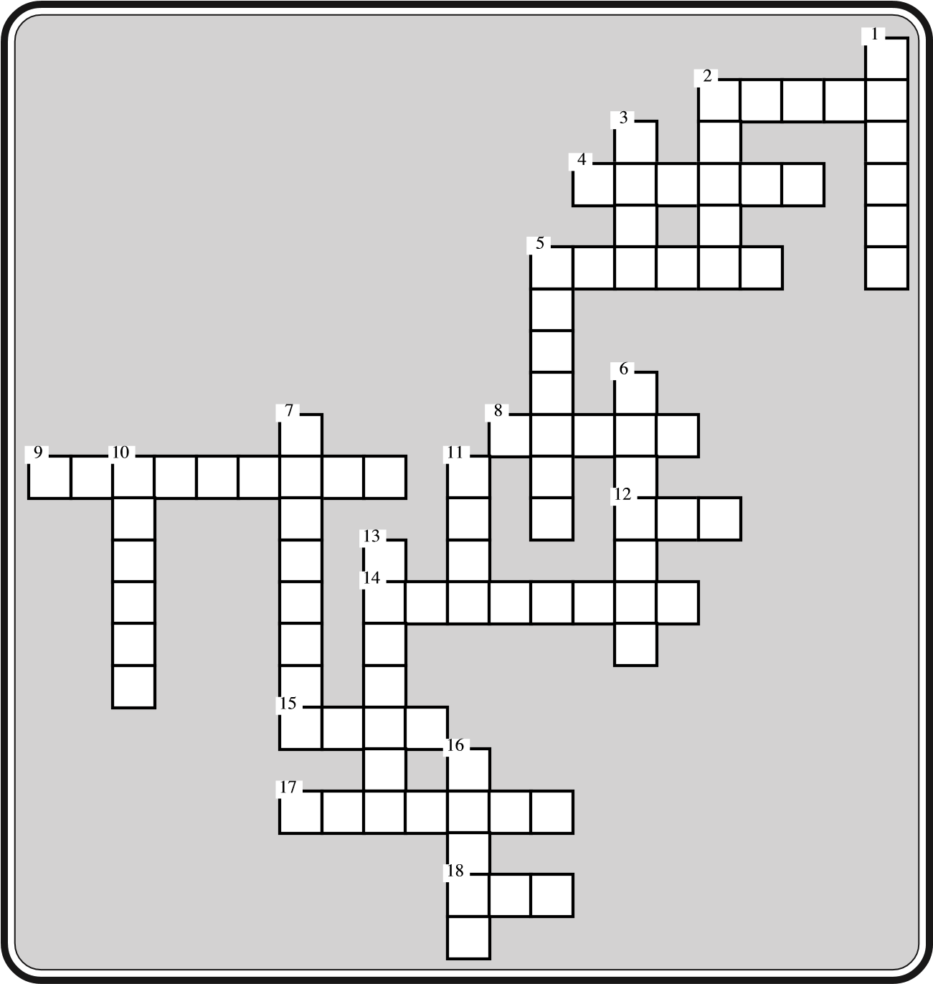
Name: ___________________ Date: __________
Physical Education 20 Crossword

Across:
2. Number of basic strokes
- It is often difficult for an experience player to play this type of player
- Only this player can score points
- He built the first US handball court in 1886
- A three person game
12. This is the type of bounce with a kill shot
- Stroke that uses the palm andcupped fingers
- This shot is usually unreturnable
- This shot goes by the opponent
- Number of faults required forserver to lose the serve
Down:
- What handball was called in Spain in the 15th century
- Times a ball can hit the floor before it must be returned
- Maximum number of players involved in a game
- Most important stroke in handball
- This shot is hit off the “fifth wall”
- As important as the hands in handball
- Width in feet of a handball court
- This is where handball originated
13. When four people are involved in a game it is called a _____ game
16. The ceiling is considered the ____ wall

Name: ___________________ Date: __________
CRCIEAEISORTIAETSRWRETKSILCAT
UTEBPTMOEEHLRSCALUIOHSSOFYSOD
MSFCAVCOLCAPIASAIWEMOAISOTTTH
OLOESIEENOVICERSOEDETIEPRUSRT
VAIHSFIFTHTWEOWUTWOGIILVVENFT
EELTITLLRDUCRSELVKILHFDWEOTHR
RVHTNTIETERGFTLFSREETEOITDCVV
HWCIGENISOCUTTHROATHMWWWOONWV
ATAPSYGWELLUUSIDEARMIPTEEUEEI
NOSMERTERCSORTOOOTGLNNTTTBKRE
DVEFNURWVORTSRTWENTYCFFDELRLT
EUYOOLOWEIRSOPRNEIAFLUIYCESEO
TSLOHFANRLOHENOVLLPROOTELSOST
DSITOWTTOWFDEEBTTEEOCTFGYURNW
EYEWDFOURSOLHOKILLLLSCHOVVSVI
RIEOPONLHEOHYTTELLOVEURRLEPTC
POORVOIIODORCPIRSMTRNOSTELEWE
SAOKILTSWIEOTHDLORAIDFFFIEDEH
LEEELSWIWLTTSSTCLOLCRYRPHIREL
Physical Education 20 Word Search
Use the clues below to discover words in the above puzzle. Circle the words.
- This shot is usually unreturnable
- This shot goes by the opponent
- A three person game
- Maximum number of players involved in a game
- Width in feet of a handball court
- This is where handball originated
- Times a ball can hit the floor before it must be returned
- The ceiling is considered the ____ wall
- As important as the hands in handball
- This is the type of bounce with a kill shot
- Only this player can score points
- When four people are involved in a game it is called a _____ game
- Stroke that uses the palm and cupped fingers
- He built the first US handball court in 1886
- This shot is hit off the “fifth wall”
- Number of basic strokes
- It is often difficult for an experienced player to play this type of player
- Number of faults required for server to lose the serve
- What handball was called in Spain in the 15th century
- Most important stroke in handball

